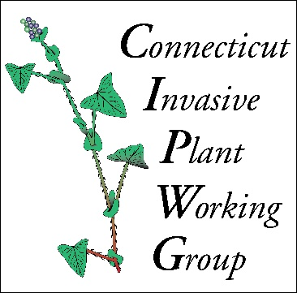**FREE INVASIVE PLANT TALK AND WALK**.

**When: May 21, 1 pm – 3 pm.**

**Where: Seabury Active Life Community, Bloomfield CT.**

**Raindate: May 22, 1 pm – 3 pm.**

**What:** Todd Mervosh and Rose Hiskes, CIPWG volunteers, will take us on a 2 hour walk around the Seabury and surrounding property and discuss the invasive species we find. They will cover identification, and management techniques. Please wear proper footwear for the hike and bring water.

**Attendance is limited to the first fifteen people who register.**  Contact Rose at [Rose.Hiskes@ct.gov](mailto:Rose.Hiskes@ct.gov) to register and get directions.

**Additional events are being planned throughout the growing season.**